

Lab 14 - Open Ended Lab - Report

Name: Muhammad Mohid
Roll No: 2530-0001
Section: BS-AI
Course: Programming Fundamentals – Lab
Course Instructor: Ms. Sadaf Ayub

Task – 1

#include<iostream>
#include<string>
using namespace std;

struct Car
{
string brand;
int year;
float price;
};

int main()
{
Car c1;

c1.brand = "Toyota";
c1.year = 2022;
c1.price = 4500000.50;

cout << "Car Brand: " << c1.brand << endl;
cout << "Manufacturing Year: " << c1.year << endl;
cout << "Car Price: " << c1.price << endl;

return 0;
}

Output

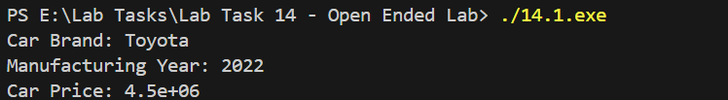

Task – 2

#include<iostream>
#include<string>
using namespace std;

struct Student
{
string name;
int rollNo;
float marks;
};

int main()
{
Student s [ 5 ];

for ( int i = 0; i < 5; i++ )
{
cout << "Enter details of student " << i + 1 << endl;

cout << "Name: ";
cin >> s [ i ].name;

cout << "Roll Number: ";
cin >> s [ i ].rollNo;

cout << "Marks: ";
cin >> s [ i ].marks;

cout << endl;
}

cout << "Student Details" << endl;
cout << "----------------" << endl;

for ( int i = 0; i < 5; i++ )
{
cout << "Student " << i + 1 << endl;
cout << "Name: " << s [ i ].name << endl;
cout << "Roll Number: " << s [ i ].rollNo << endl;
cout << "Marks: " << s [ i ].marks << endl;
cout << endl;
}

return 0;
}

Output

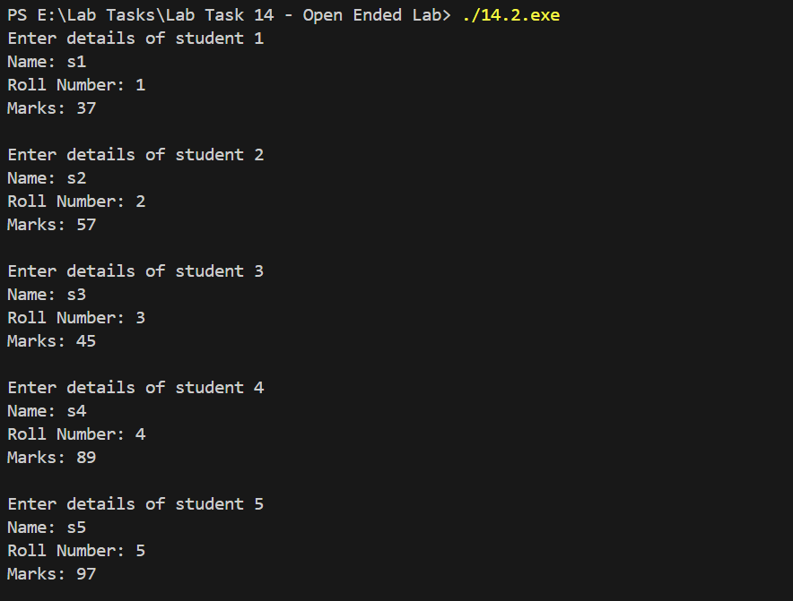
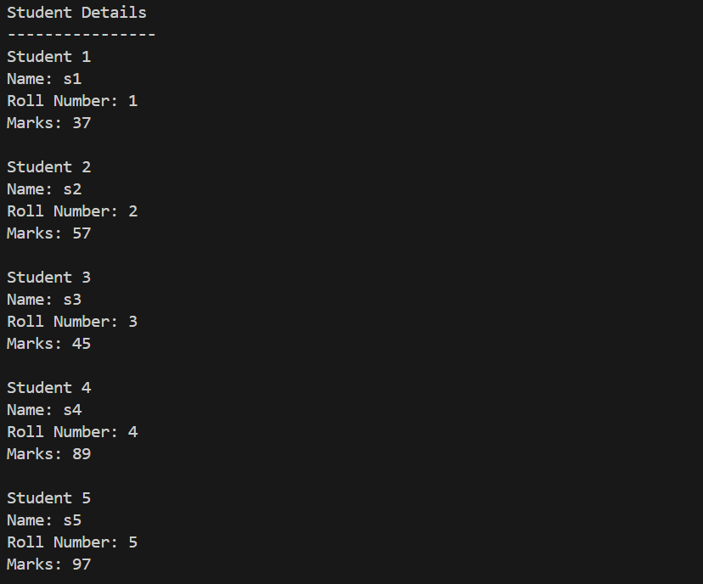

Task – 3

#include<iostream>
using namespace std;

struct Rectangle
{
float length;
float breadth;
};

float calculate_area ( Rectangle r )
{
float a = r.length * r.breadth;
return a;
}

float calculate_perimeter ( Rectangle r )
{
float p = 2 * ( r.length + r.breadth );
return p;
}

int main()
{
Rectangle rect;

cout << "Enter Length: " << endl;
cin >> rect.length;

cout << "Enter Breadth: " << endl;
cin >> rect.breadth;

float area = calculate_area ( rect );
float perimeter = calculate_perimeter ( rect );

cout << "Area of Rectangle: " << area << endl;
cout << "Perimeter of Rectangle: " << perimeter << endl;

return 0;
}

Output

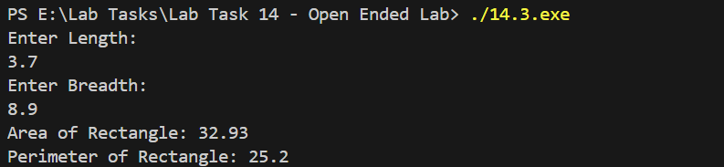

Task – 4

#include <iostream>
#include <string>

using namespace std;

struct Book
{
string title;
string author;
float price;
};

int main()
{
Book b1, b2;

cout << "Enter details of first book" << endl;

cout << "Title: ";
getline ( cin, b1.title );

cout << "Author: ";
getline ( cin, b1.author );

cout << "Price: ";
cin >> b1.price;

cin.ignore();

cout << endl;

cout << "Enter details of second book" << endl;

cout << "Title: ";
getline ( cin, b2.title );

cout << "Author: ";
getline ( cin, b2.author );

cout << "Price: ";
cin >> b2.price;

cout << endl;

if ( b1.price > b2.price )
{
cout << "Book with higher price:" << endl;
cout << "Title: " << b1.title << endl;
cout << "Author: " << b1.author << endl;
cout << "Price: " << b1.price << endl;
}
else if ( b2.price > b1.price )
{
cout << "Book with higher price:" << endl;
cout << "Title: " << b2.title << endl;
cout << "Author: " << b2.author << endl;
cout << "Price: " << b2.price << endl;
}
else
{
cout << "Both books have the same price." << endl;
}

return 0;
}

Output

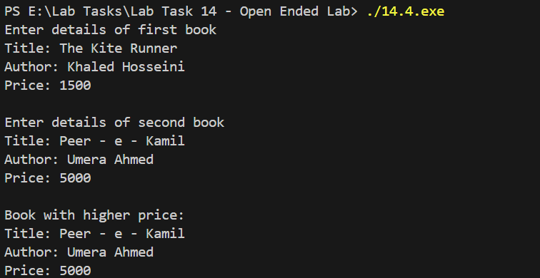

THE END

